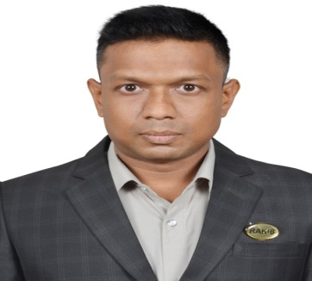
Mohammad Rakibul Islam.
Contact: +88 01723297417.
Mail: rakib.ice07@gmail.com
WhatsApp: +88 01759265706.
IMO: +88 01723297417.

Objective:
My passion is ASP.NET Core. So I want to became a professional ASP.NET Developer.
Educational Qualification: B.Sc Degree in Information & Communication
Engineering from Islamic University.

Skills:

Programming Languages: C, C#.

Markup Languages: HTML, CSS.

Database:

Entity Framework Core 6 :
- Code First,
- Models & Data Context,
- Constraints, Keys & Relationships,
- Data Access ( Create, Read, Update & Delete),
- Stored Procedures, Views & Functions,
- Sorting, Filtering & Paging,
- LINQ for Queries and Projections,
- Repository & Unit of Work Patterns,
- Asynchronous Data Operation.
ASP.NET Core:
- Controllers with Views,
- Razor Pages,
- View Components,
- Tag Helpers,
- Build-in Tag Helpers,
- Forms Tag Helpers,
- Model Binding,
- Model Validation,
- Using Filters,
- Creating From Application,
- Identity,
- URL Routing.
Languages: English, Bengali.

